KWAME NKRUMAH UNIVERSITY OF SCIENCE AND TECHNOLOGY KUMASI, GHANA

COLLEGE OF ENGINEERING
DEPARTMENT OF ELECTRICAL/ELECTRONIC ENGINEERING
COE 381 (MICROPROCESSORS)
AUTOMATED DOOR LOCK SYSTEM
APRIL 5TH, 2026

GROUP MEMBERS
1. TAYLOR ERNESTINA ELORM EWURA EKUA - 7344023
2. BOA-AMPONSEM KWABENA KWADU – 7342823
3. FREDRICK AGYENIM BOATENG – 7341723
4. REYNOLDS OTSIEDU – 7342223
5. SARKORDIE, KWABENA RICHARD - 1874322

ACKNOWLEDGEMENT
We express our thanks to the almighty God for bringing us this far and helping us complete this project.

Table of Contents
1. Introduction ............................................................. 3
2. Problem Statement ....................................................... 3
3. Objectives .............................................................. 3
4. Methodology ............................................................. 4
5. System Components ....................................................... 4
6. System Design and Schematic ............................................. 5
7. Code Overview ........................................................... 5
8. Simulation and Demonstration ............................................ 6
9. Results and Discussion .................................................. 6
10. Possible Improvements .................................................. 7
11. Conclusion ............................................................. 7
12. References ............................................................. 8

1. Introduction
Security is a fundamental need in both residential and commercial environments. Traditional mechanical locks, while widely used, are increasingly inadequate against modern security threats due to their susceptibility to picking, duplication, and forced entry. The rapid advancement of embedded systems and microcontroller technology has opened the door to smarter, more reliable security solutions.

This project presents the design and implementation of an Automated Door Lock System using an Arduino microcontroller, a 4x4 matrix keypad for PIN-based authentication. The system is simulated using Tinkercad, a widely used online circuit simulation platform, which allows verification of hardware logic and software behaviour without the need for physical components.

2. Problem Statement
Conventional door locking mechanisms rely entirely on physical keys, which can be lost, stolen, copied, or forgotten. This creates significant security vulnerabilities, especially in environments with multiple users requiring access, such as dormitories, laboratories, and office spaces. Furthermore, there is no audit trail or intelligent control mechanism to monitor or restrict access in real time.

There is therefore a need for a cost-effective, intelligent, and reliable automated access control system that eliminates the dependence on physical keys while supporting multiple authentication modes and providing user feedback for granted or denied access attempts.

3. Objectives
The specific objectives of this project are:

- To design an automated door lock system using an Arduino Uno microcontroller.
- To implement PIN-based authentication using a 4x4 matrix keypad.
- To provide real-time user feedback through an LCD display and LED indicators.
- To control a servo motor representing the door lock mechanism.
- To simulate and validate the complete system using Tinkercad.

4. Methodology
The project was developed using a structured, iterative approach. The team began by reviewing relevant literature and similar embedded security systems to identify appropriate components and design strategies. System requirements were then defined, followed by hardware selection and circuit design in Tinkercad.

The Arduino sketch was written in the Arduino IDE, implementing logic for both keypad PIN entry and RFID card scanning. Each authentication mode was developed and tested independently before integration. The simulation was run in Tinkercad to verify correct operation, and the code was refined based on simulation feedback. Finally, the team documented findings and prepared this report and the associated video presentation.

6. System Design and Schematic
The circuit was designed and simulated entirely within Tinkercad. The Arduino Uno serves as the central processing unit, with all peripheral components connected through its digital and analog I/O pins.

7. Code Overview
The system firmware was written in C++ using the Arduino IDE. The code was structured into well-commented functional blocks to improve readability and maintainability.

8. Simulation and Demonstration
The complete system was simulated using Tinkercad Circuits. The simulation allowed the team to verify the correctness of the circuit connections, test the firmware logic, and observe the real-time behaviour of all output components.

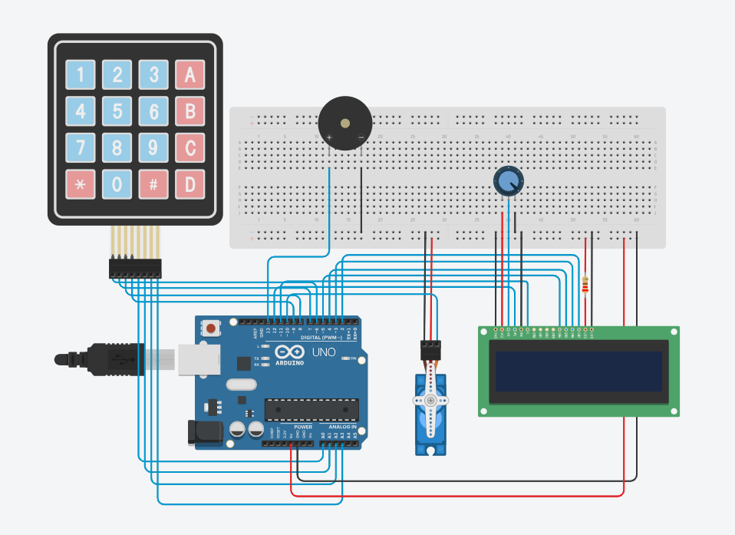

9. Results and Discussion
The simulation results demonstrated that the Automated Door Lock System functions correctly across all designed authentication scenarios. The keypad successfully captured user input, and PIN comparison logic operated without errors.

The servo motor responded accurately to grant and denial signals, reliably rotating to the unlock position upon successful authentication and returning to the locked state after the timeout period. The LCD display provided clear and timely feedback throughout all interactions, enhancing user experience.

The lockout mechanism functioned as designed, restricting further input after three consecutive failed attempts, thereby providing a basic brute-force prevention feature. The auditory (buzzer) and visual (LED) indicators successfully complemented the LCD feedback, creating a multi-modal user interface.

10. Possible Improvements
- Integration of a GSM or Wi-Fi module (e.g., ESP8266) to enable remote unlocking and real-time SMS or push notification alerts.
- Addition of a fingerprint sensor for biometric authentication, providing a third, highly secure access mode.
- Logging of access events (successful and failed attempts) to an SD card or cloud database for audit trail purposes.
- Implementation of a mobile application to manage authorised PINs and RFID UIDs remotely.
- A real-time clock (RTC) module could enable time-based access restrictions (e.g., access only during business hours).

11. Conclusion
This project successfully demonstrated the design and simulation of a dual-mode Automated Door Lock System using an Arduino Uno microcontroller. The Tinkercad simulation validated the circuit design and software logic across all test scenarios, confirming the system's reliability and correctness. The project reinforced key concepts in microcontroller programming, embedded systems design, sensor integration, and hardware-software co-design.

The proposed improvements, if implemented in a physical prototype, would significantly enhance the system's capability, scalability, and real-world applicability, making it suitable for deployment in homes, offices, and institutional environments.

12. References
[1] Banzi, M. & Shiloh, M. (2022). Getting Started with Arduino (4th ed.). Maker Media.

[2] Arduino LLC. (2024). Arduino Reference Documentation. Retrieved from https://www.arduino.cc/reference/en/

[3] NXP Semiconductors. (2016). MFRC522 Standard performance MIFARE and NTAG Frontend Datasheet.

[4] Autodesk Tinkercad. (2024). Tinkercad Circuits Simulation Platform. Retrieved from https://www.tinkercad.com

[5] Mazidi, M. A., McKinlay, R. D., & Causey, D. (2017). Arduino Microcontroller Processing for Everyone! (3rd ed.). Pearson.

